**Software Engineering Project**

**Report**

**Smart parking**

Report #2: SYSTEM DESIGN

Reference:*https://github.com/software-groupp/smart-parking*

Group member and Individual Contributions Breakdown：

1. Thomas：Use Case4 :Camera sensor,Use Case5 :Timer,Class Diagram4＆5, Identifying Subsystems,Mapping Subsystems to Hardware，User Interface Design and Implementation ；

Evan:Use Case1 :Payment,Use Case2 :Parking ,Use Case3:Going out，Class Diagram1，2＆3, Architectural Styles；

Alex:Use Case6 :No Availability,Use Case7 :Register，Class Diagram6＆7,Persistent Data Storage,Network Protocol ；

Alan:Use Case8 :Sensors,Use Case9 :ad-hoc,，Class Diagram 8＆9

,Global Control Flow,Hardware Requirements.

Contents

A.Interaction Diagrams 3

1. Use Case1 :Payment 3

2.Use Case2 :Parking 4

3.Use Case3:Going out 4

4.Use Case4 :Camera sensor 5

5.Use case5:Timer 6

6.Use Case6 :No Availability 6

7.Use Case7 :Register 7

8.Use Case8 :Sensors 8

9.Use Case9 :ad-hoc 9

B.Project Management 10

2. Class Diagram and Interface Specification 11

a. Class Diagram 11

3. System Architecture and System Design 15

a. Architectural Styles 15

B. Identifying Subsystems 16

C. Mapping Subsystems to Hardware 16

D. Persistent Data Storage 16

E. Network Protocol 17

F.Global Control Flow 17

G.Hardware Requirements 17

4. User Interface Design and Implementation 17

# A.Interaction Diagrams

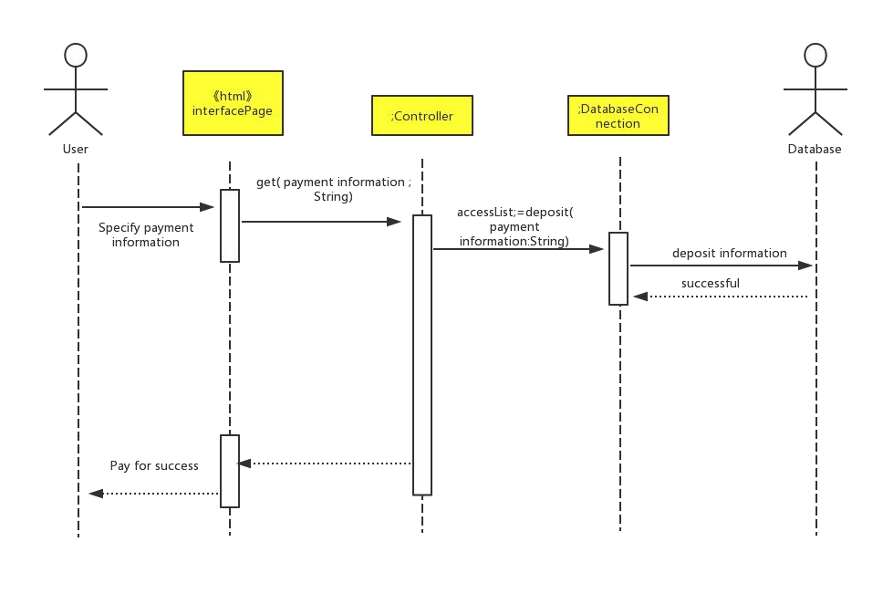1.Use Case1 :Payment

2.Use Case2 :Parking

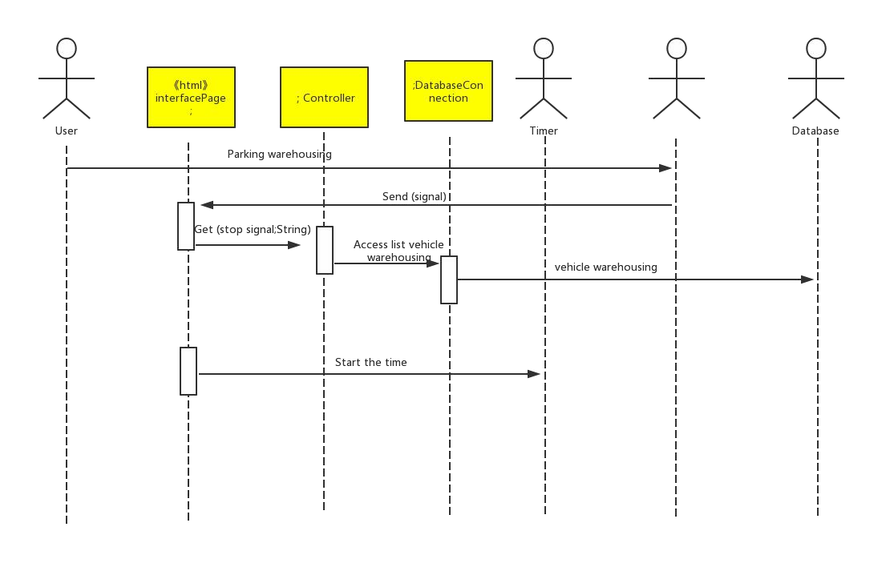

3.Use Case3:Going out

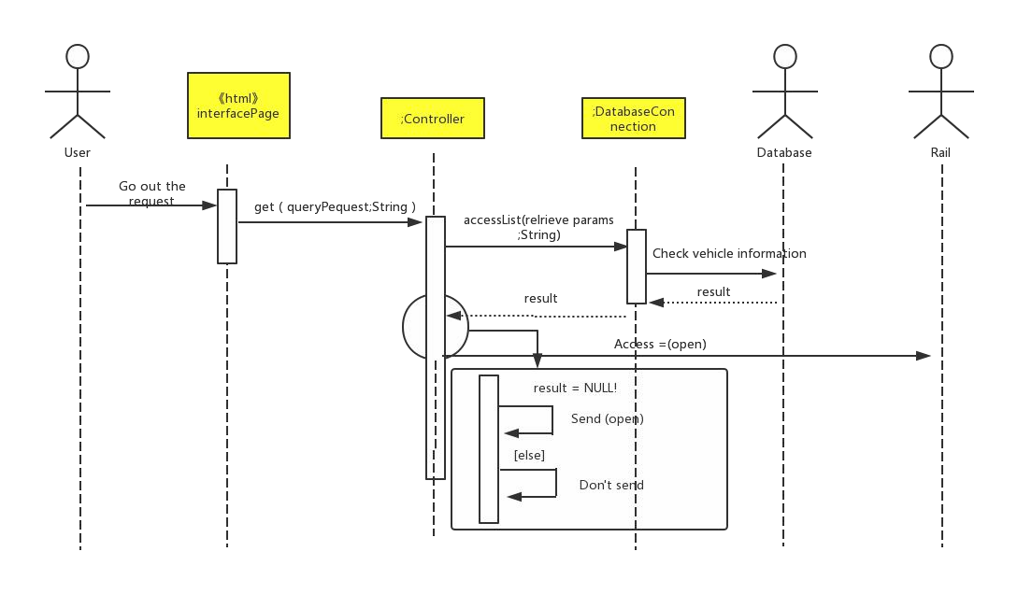

4.Use Case4 :Camera sensor

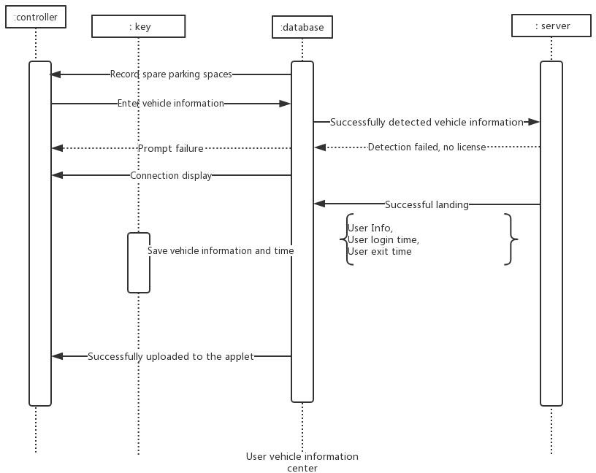

5.Use case5:Timer

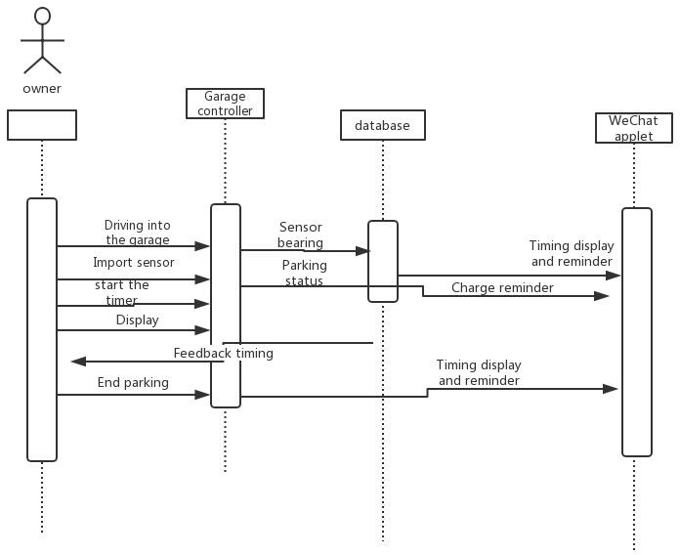

6.Use Case6 :No Availability

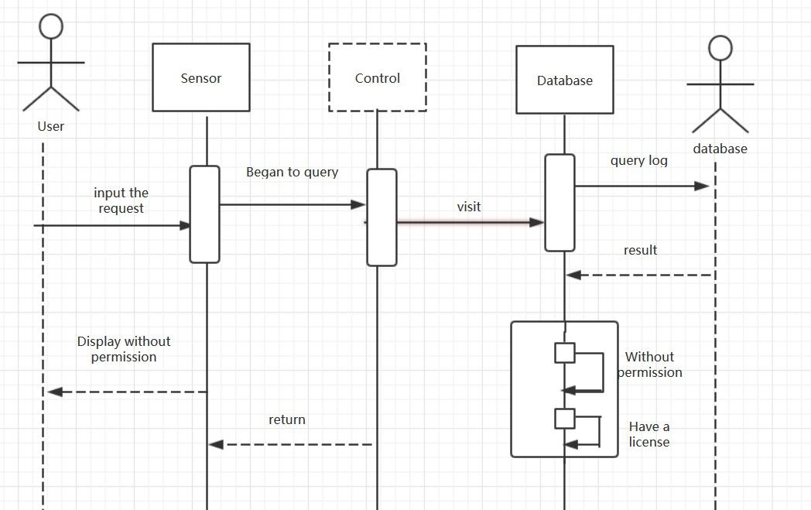

7.Use Case7 :Register

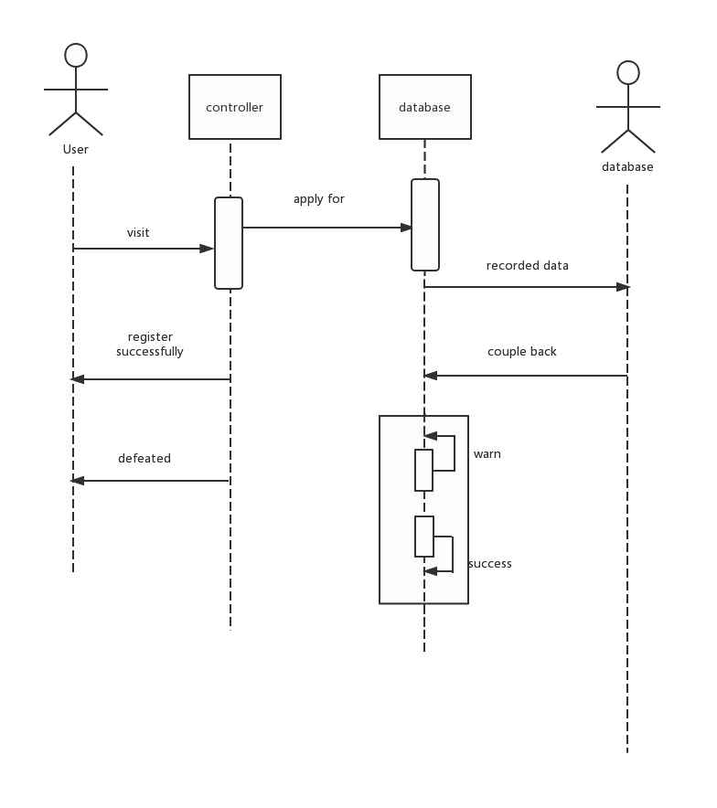

8.Use Case8 :Sensors

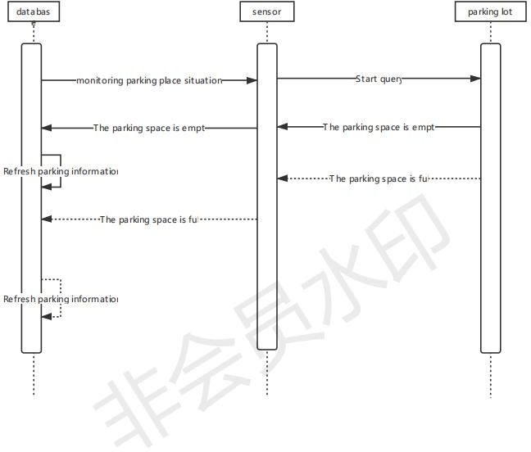

9.Use Case9 :ad-hoc

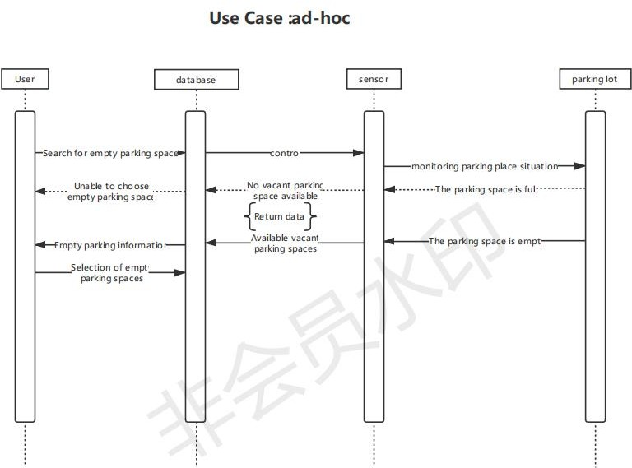

# B.Project Management

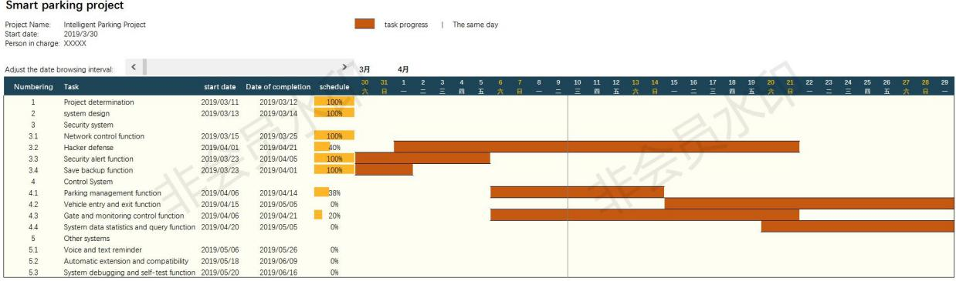

# References <http://staruml.sourceforge.net/en/> [https://www.processon.com](https://www.processon.com/) <http://argouml.tigris.org/>

1. Class Diagram and Interface Specification
2. Class Diagram

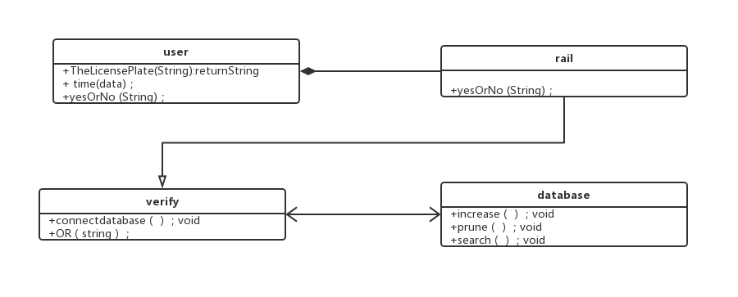

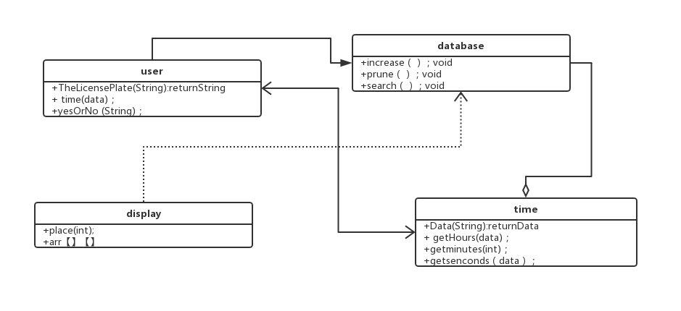

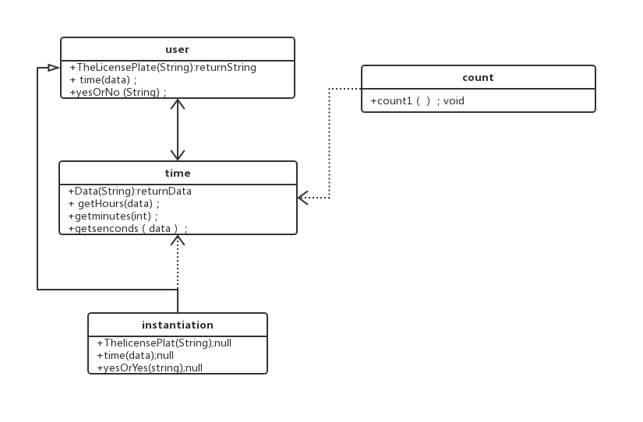

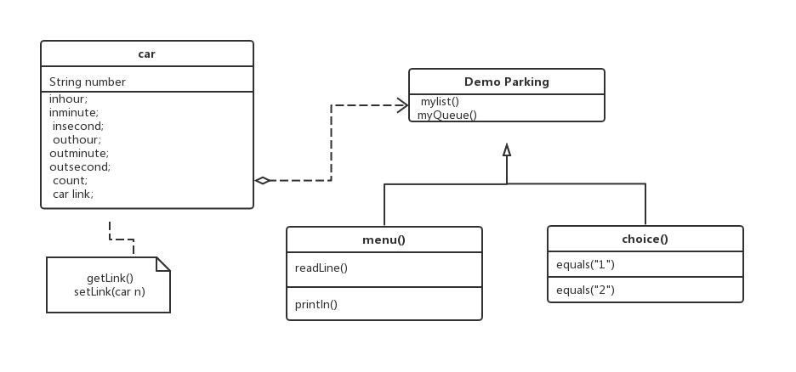

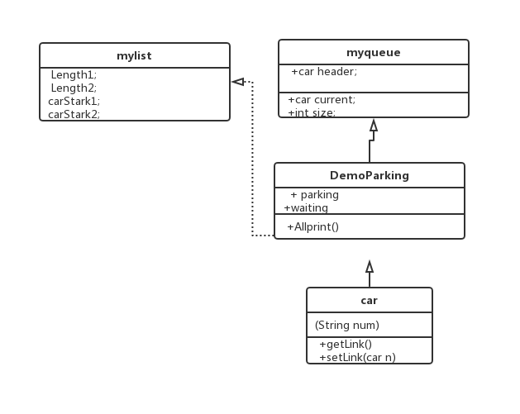

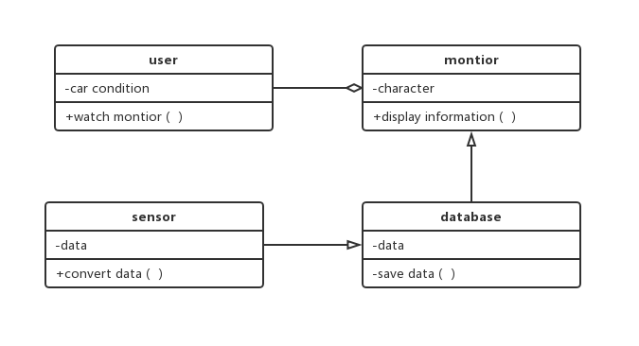

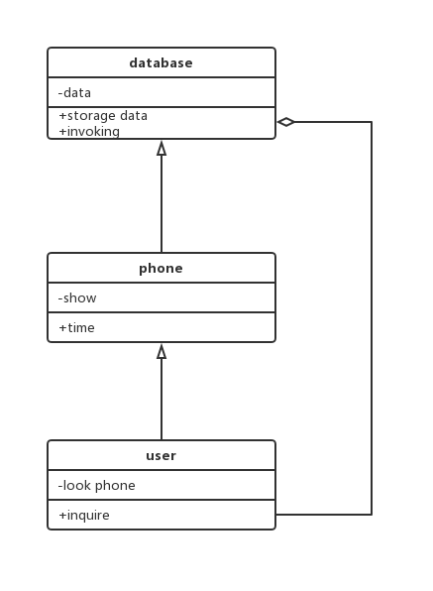

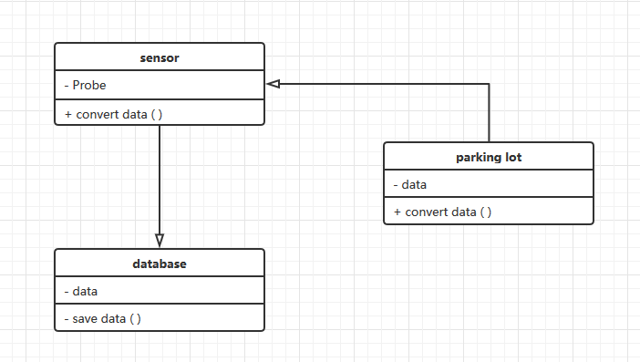

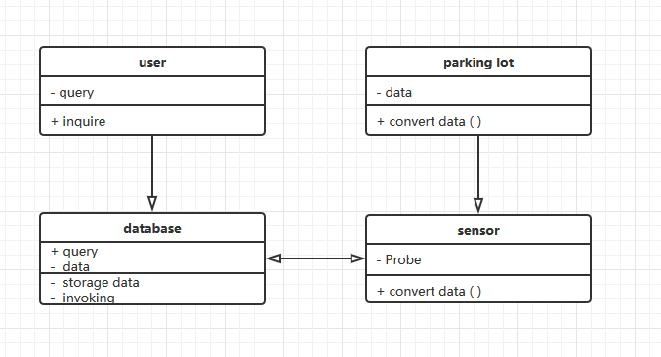

1. System Architecture and System Design
2. Architectural Styles

Data abstraction and object-oriented style

The abstract data type concept plays an important role in software systems. Currently, the software industry has generally turned to object-oriented systems. This style is based on data abstraction and object-oriented, and the representation of data and their corresponding operations are encapsulated in an abstract data type or object. This style of artifact is an object, or an instance of an abstract data type. An object is a component called a manager because it is responsible for maintaining the integrity of the resource. Objects interact through calls to functions and procedures.

Figure 2-2 is a schematic diagram of data abstraction and object-oriented style.

1. Identifying Subsystems

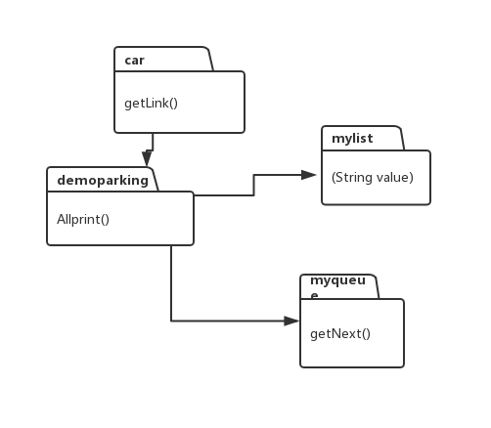

1. Mapping Subsystems to Hardware

Our software has its own server, then you can call it on other websites.

1. Persistent Data Storage

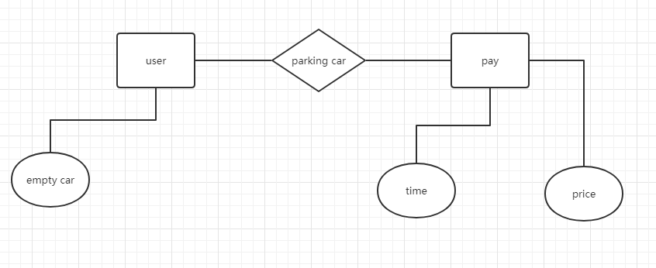

1. Network Protocol

We choose HTTP protocol because the main protocol used by WWW server is HTTP protocol, namely hyper style transport protocol. Since the services supported by HTTP protocol are not limited to WWW, but also other services, HTTP protocol allows users to use different protocols to access different services under a unified interface.

F.Global Control Flow

Execution orderness:Our system is an event-driven system.

Time dependency:Our system is event-response type.

Concurrency:our system does not use multiple threads.

G.Hardware Requirements

Server and client computers:Processor Intel (R) Core (TM) i3,Memory 8 GB or more,A color display with a minimum resolution of 640x480 pixels is required,minimum network bandwidth 10 Mbps,At least 100GB of hard disk space and Uninterruptible Power Supply.

Other hardware:Multiple LED Electronic Display Screens,Digital Vehicle Detector,Control Card Reader, Gangting Card Reader, Card Distributor, Horn, Automatic Card Distributor, Infrared Detector, Video Card, Serial Port Extension Card, Intelligent Gate,Surveillance camera.

1. User Interface Design and Implementation

